



Monitoring Server’s Guide:

Azure

Date: Oct 2021

R.sharma@projectobjects.com

**Author: Raunak Sharma**

Contents

1.Introduction: 3

2. Login on Azure Portal: 3

2.1 Project Objects Ltd. 3

2.2 UppwiseSrl 4

3. Path to Server monitoring section: 4

4. List of frontend web servers need to monitor at project objects side: 7

5. List of frontend web servers need to monitor at UPPWISE subscription: 7

6.Points of contact in case of any Outage 7

6.1 Outage Criteria 7

6.2Emergency Alerts 7

6.2.1Primary contact- 8

6.2.2 Secondary Contact- 8

6.2.3 Use below contacts in case of unreachability of all above persons 8

7.Steps to Prepare Standard reports: 8

7. Nestle Table Lock Monitoring 9

7.1 Path 9

7.2 Alert/Flagged state criteria 10

7.3 Status Report for Lock monitoring 10

8.Sequence of Environments and Mail recipients for reports: 11

9. RDP connection of System 11

8.1 How to install software 11

# 1.Introduction:

This article describes the different steps required for a complete Monitoring of Azure resources. The goal of a complete implementation of Azure Monitor is to collect all available data from all your cloud resources and applications and different kinds of data and enables different kinds of analysis and alerting.

# 2. Login on Azure Portal:

## 2.1 Project Objects Ltd.

Please follow below procedure to login Azure Portal:

1.Go to Azure Portal Login (<https://portal.azure.com/>)

2.Sign in with Microsoft account

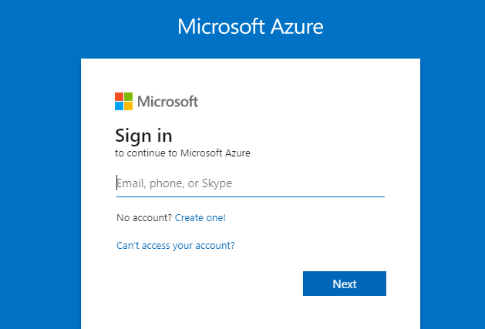

3.Fill the ID and password and select next.

**UID-** [SSP@Projectobjects.com](mailto:SSP@Projectobjects.com)

## 2.2 UppwiseSrl

Please follow below procedure to login Azure Portal:

1.Go to Azure Portal Login (<https://portal.azure.com/>), in different browser

2.Sign in with Microsoft account



3.Fill the ID and password and select next.

**UID**- SSP@uppwise.com

# 3. Path to Server monitoring section:

After login Go to Portal Menu

At left hand side click over portal menu and scroll down to find Virtual Machines and click on It

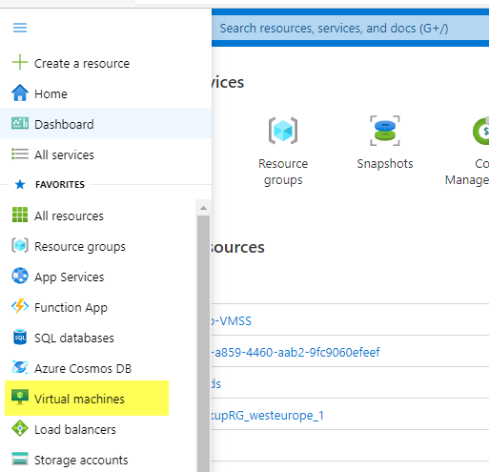

Or you can type Virtual Machine in search bar on portal and find VM from there also.

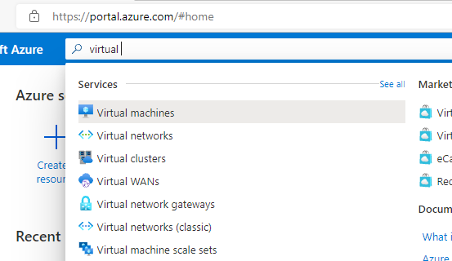

Then select the VM from the list and click on It.

For e.g select Live Web server

Then select Monitoring at overview page

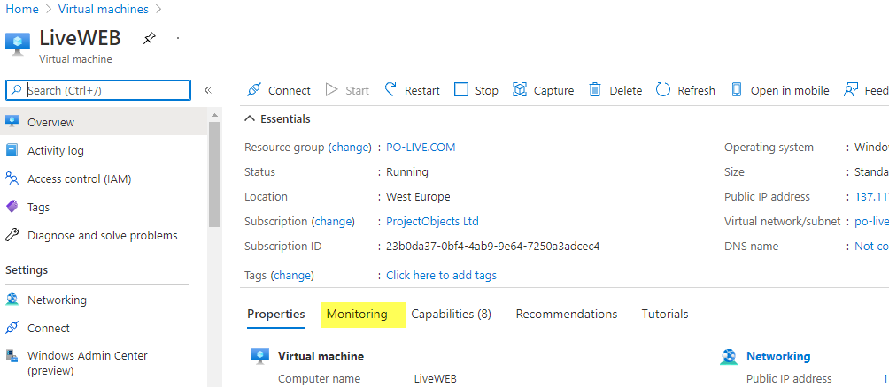

Click on metrics graphs which you want to see.

Below screen shows CPU percentage graphs-

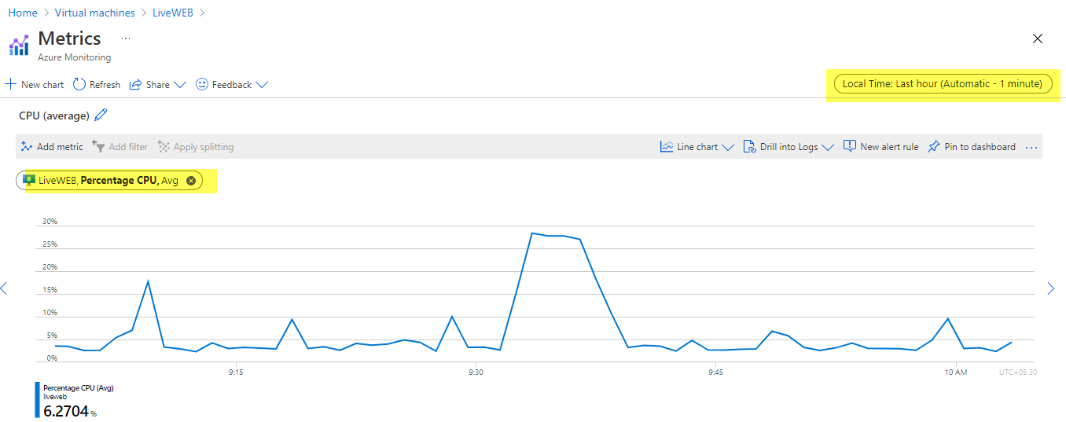

We can also change the Time (Zone and custom date range) and aggregation (Avg,Max,Min)

As shown in above screenshot.

**Note:** Monitor CPU Percentage and Available Memory metrics continuously for each Frontend Web servers mentioned in below list

# 4. List of frontend web servers need to monitor at project objects side:

1.Live Web

(Associated Database backend server- LiveSql2012)

2.PoliveTrial

(Associated Database backend server- POLiveTrialSQL)

3.LiveApp-PO9

(Associated Database backend server- LiveSql2012)

4.NestleApp-VMSS

(Associated Database backend server- NestleSql)

5.USRenal-APP

(Associated Database backend server- USRenal)

**Note:** NestleApp-VMSS is virtual machine scale sets, and it is separate service from virtual machine. For this type of virtual machine scale sets in search bar and then select it.

Monitoring steps will be same as virtual machines

# 5. List of frontend web servers need to monitor at UPPWISE subscription:

1.SPM-APP

(Associated Database backend server- SPM)

# 6.Points of contact in case of any Outage

## 6.1 Outage Criteria

Any of web server’s average CPU usage reached above 70% continuously for 10 minutes.

## 6.2Emergency Alerts

The persons need to contact at time of any outage are in the order listed:

### 6.2.1Primary contact-

|  |  |  |  |
| --- | --- | --- | --- |
| **S.No** | **Name** | **M.NO** | **Email ID** |
| 1 | Raunak Sharma | 9045173731 | [R.sharma@projectobjects.com](mailto:R.sharma@projectobjects.com) |

### 6.2.2 Secondary Contact-

|  |  |  |  |
| --- | --- | --- | --- |
| S.No | Name | M.NO | Email ID |
| 1 | Jyoti Kataria | 9971729605 | [j.kataria@projectobjects.com](mailto:j.kataria@projectobjects.com) |

### 6.2.3 Use below contacts in case of unreachability of all above persons

|  |  |  |  |
| --- | --- | --- | --- |
| S.No | Name | M.NO | Email ID |
| 1 | Ravi Gupta | 9990991980 | [r.gupta@projectobjects.com](mailto:r.gupta@projectobjects.com) |
| 2 | Vishal Gour | 9899751138 | [v.gour@projectobjects.com](mailto:v.gour@projectobjects.com) |

# 7.Steps to Prepare Standard reports:

To prepared standard report for monitoring metrics for each server’s

Collect Insights of different metrics

Go to monitoring section from left hand side in VM & VMSS and Select Insights

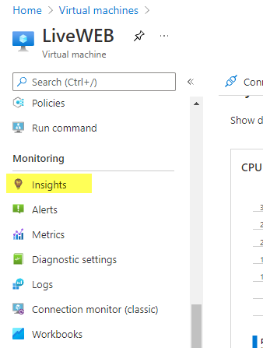

Click on Performance

Click aggregate chart,

Check on Avg, Max and Min in Check box

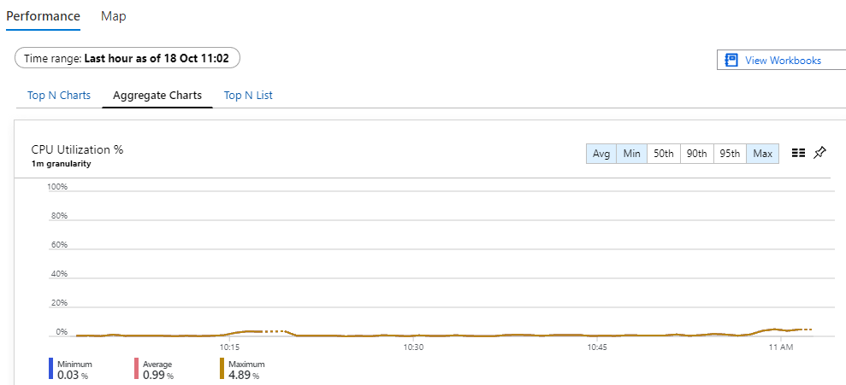

Collect snapshots of graphs for **CPU utilization, Available Memory, and Network IN and OUT**.

# 7. Nestle Table Lock Monitoring

## 7.1 Path

1. Browse the below link-

<https://nimtdashboard.po-live.com/lock_monitor>

1. Use below credentials to login-

UID- [admin@pomonitoring.com](mailto:admin@pomonitoring.com)

PW- ThisIsMonitoringPassword75025!

1. After login screen will look like below screenshot

1. This table will automatically get refreshed in every 5 seconds.
2. We need to monitor the session ID, duration of session, Host, and client in the table.

## 7.2 Alert/Flagged state criteria

Step1. If for session ID duration of session(sec) reached to 180 and the client is OLEDB then Alert mail is to be fired with screenshot.

Step2. If for same session ID duration of session(sec) reached to 300 and the client is OLEDB then primary contact person need to be contacted.

## 7.3 Status Report for Lock monitoring

The status of the lock monitoring is to be provided along with the mail of nestle environment health report is sent.

Add summary status for lock monitoring in separate section of mail.

# 8.Sequence of Environments and Mail recipients for reports:

Use standard PPT report shared as reference and generate reports for environments sequentially at every half hour and share it on below address mails:

1. [R.sharma@Projectobjects.com](mailto:R.sharma@Projectobjects.com)
2. [R.Gupta@projectobjects.com](mailto:R.Gupta@projectobjects.com)
3. [J.kataria@projectobjects.com](mailto:J.kataria@projectobjects.com)

Follow below sequence of environment for reports:

1.LiveWeb and LiveSql2012 servers (Live Environment)

2.NestleApp-VMSS and NestleSQL-Primary and NestleSQL-Secondary (Nestle Environment)

3.PoLiveTrial and POliveTrialSQL servers (LiveTrial Environment)

4.Urenal-APP and USRenal servers (US environment)

**5. SPM-APP and SPM Servers (UPPWISE Subscription)**

# 9. RDP connection of System

When monitoring will be started the system needs to connect with our multiple system at same time, so that at any point of time we can take any information or can help in any emergency if needed which will provide redundancy for our monitoring structure.

For this we will use **Anydesk** software

## 9.1 How to install software

1. Download software from below link

[Download AnyDesk for Free](https://anydesk.com/en/downloads)

1. After downloading it click on Install Anydesk on this device

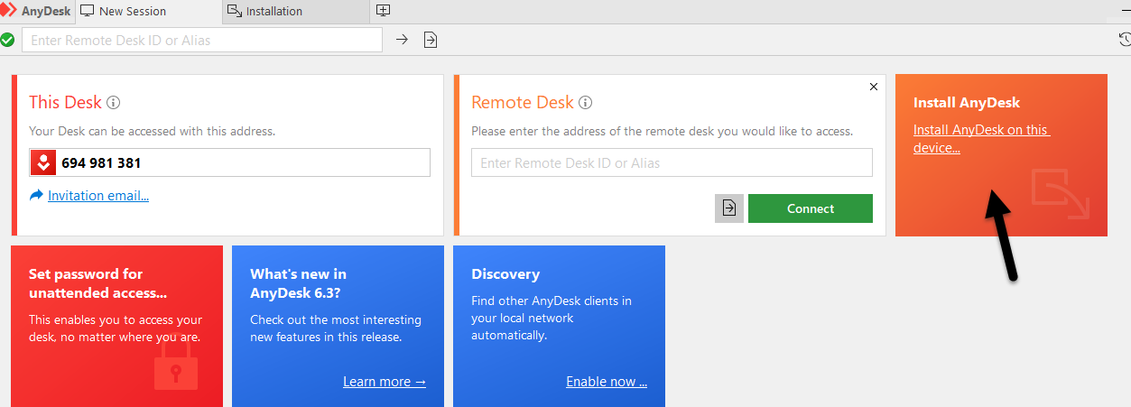

1. select the required checkbox and click on Accept and install

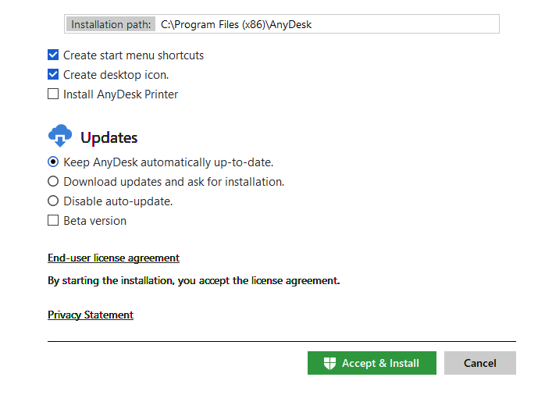

1. After installing open anydesk and set password for device (Set pw- **Poi@2011**)

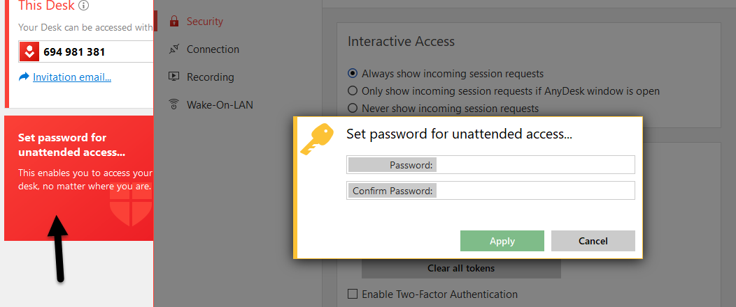

1. Click on Apply.

**Note:** At time of login open Anydesk daily and minimise it, do not cancel the anydesk throughout the monitoring hours.